**MOMENTS WORTH PAYING FOR PRESENTS   
A SPECIAL MESSAGE FROM THE CAST OF**

**FURIOSA: A MAD MAX SAGA**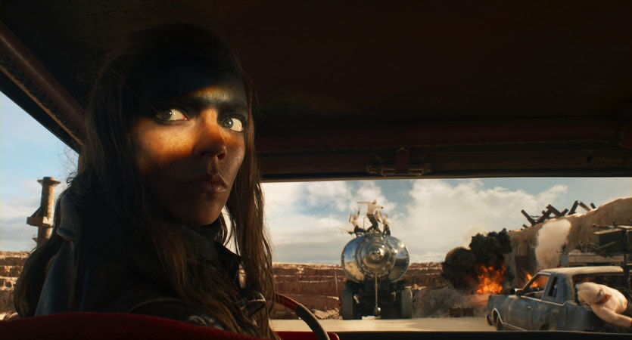

Watch the video [HERE](https://youtu.be/nLcTPBXMNtY)

Download the video [HERE](https://base1.box.com/s/dkqs0ai2w2rg0j8rhmi5yt76ule0ides)  
Download images [HERE](https://base1.box.com/s/g15tl4wgpf3t4ybxss1a11y1gqfhwmuu)

*Thursday 11th April, 2024:* Today, Moments Worth Paying For presents an exclusive message for UK audiences from the stars of Warner Bros. Pictures’ **FURIOSA: A MAD MAX SAGA** ahead of its release only in cinemas on 24 May.

In the exclusive and brand-new content, Anya Taylor-Joy and Chris Hemsworth tell audiences why the cinema is the best and only place to catch the George Miller's **FURIOSA: A MAD MAX SAGA.**

*As the world fell, young Furiosa is snatched from the Green Place of Many Mothers and falls into the hands of a great Biker Horde led by the Warlord Dementus. Sweeping through the Wasteland, they come across the Citadel presided over by The Immortan Joe. While the two Tyrants war for dominance, Furiosa must survive many trials as she puts together the means to find her way home.*

**Liz Bales**, **Chief Executive** at **British Association *for* Screen Entertainment** said: *"After 13 years of the Moments Worth Paying For campaign, which has generated £95m in media value and reached a total audience of 6.4 billion people, we today launch our first trailer of 2024 with Hollywood stars Anya Taylor-Joy and Chris Hemsworth emphasising the enduring importance of experiencing films like****Furiosa: A Mad Max Saga****first on the big screen, at your local cinema. The latest BASE research continues to demonstrate the campaign's positive impact on cinema-goers and their infringement behaviour and attitudes. If the creative community can work together to combat piracy, we have the tools and the knowledge to achieve maximum impact and effect. I'd like to thank our partners at DCM, Pearl & Dean, ClearChannel UK, UK Cinema Association, and our many distributor members for your continued support in bringing this message to the big screen and beyond. We look forward to showcasing more brilliant films throughout the rest of the year."*

**Alexandra Lewis, Senior Vice President Marketing, Warner Bros. Discovery U.K. & Ireland,**said “We’re proud to partner with BASE again, this time working with the outstanding Anya Taylor-Joy and Chris Hemsworth in George Miller’s highly anticipated *Furiosa: A Mad Max Saga*, to support the hugely important *Moments Worth Paying For* campaign. There is nothing quite like experiencing an epic movie on the big screen and Warner Bros. Discovery is proud to partner with this programme to help drive this important message.”

***Furiosa: A Mad Max Saga* is released exclusively in UK & Irish cinemas on May 24, 2024.**

Find your nearest screening [here](https://www.warnerbros.co.uk/movies/furiosa-mad-max-saga).

Warner Bros. Pictures Presents A Kennedy Miller Mitchell Production, A George Miller Film, *Furiosa: A Mad Max Saga*. The film will be distributed worldwide by Warner Bros. Pictures.

For further press information about Moments Worth Paying For, please contact  
  
Nicki Foster, Kelsey O’Connor, Chloe Middlebrook  
[firstname.surname@premiercomms.com](mailto:firstname.surname@premiercomms.com)

For enquiries on *FURIOSA: A MAD MAX SAGA* please contact:

[Publicity.uk@wbd.com](mailto:Publicity.uk@wbd.com)

**SOCIAL CHANNELS:**

<https://facebook.com/warnerbrosuk>

<https://twitter.com/WarnerBrosUK>

<https://instagram.com/warnerbrosuk/>

<https://warnerbros.com/>